**SELF-DISCLOSURE FORM**

Congratulations on being shortlisted for an interview at Lawnswood School.

**Please review the flowcharts on pages 3-4 and then complete and return this disclosure form as soon as possible, and no later than one working day prior to interview, to** [**hr@elawnswood.co.uk**](mailto:hr@elawnswood.co.uk)**. Candidates may be asked for further information during the recruitment process.**

If we have not received this form, we reserve the right to withdraw the offer of interview.

|  |  |  |
| --- | --- | --- |
| Post applied for: | | Interview Date: |
| Full name and title (including all previous names and preferred names): |  | |
| Date of birth: |  | |
| National Insurance No: |  | |
| Teacher reference number (if applicable): |  | |
| Date of recognition as qualified teacher (QTS) (if applicable): |  | |

**Lawnswood School is committed to safeguarding and promoting the welfare of children and we expect all staff, volunteers, visitors and contractors to share this commitment. This post is exempt from the Rehabilitation of Offenders Act 1974; pre-employment checks will be carried out, references will be sought and successful candidates will be subject to an enhanced DBS check, online search and other relevant checks in line with statutory guidance.**

We comply with the Disclosure & Barring Service (DBS) code of practice and have a written policy on the recruitment of ex-offenders, both of which are available on request. As you have been shortlisted for interview, you are required to declare any relevant convictions, adult cautions or other matters which may affect your suitability to work with children. As a result of amendments to the Rehabilitation of Offenders Act 1974 (exceptions order 1975) in 2013 and 2020, some minor offences are now protected (filtered) and should not be disclosed to potential employers, and employers cannot take these offences into account. Please see attached flowcharts for reference.

Please read the information [here](http://www.gov.uk/tell-employer-or-college-about-criminal-record) before answering the following questions. If you are unsure whether you need to disclose criminal information, you should seek legal advice or you may wish to contact Nacro or Unlock for impartial advice. There is more information on filtering and protected offences on the Ministry of Justice website: Nacro - <https://www.nacro.org.uk/criminal-record-support-service/> or email [helpline@nacro.org.uk](mailto:helpline@nacro.org.uk) or phone 0300 123 1999.

|  |
| --- |
| 1. Do you have any convictions or adult cautions that are unspent? **Yes / No** |
| If yes, please provide details here |
| 1. Do you have any other cautions or convictions that would not be filtered? **Yes / No** |
| If yes, please provide details here |
| 1. Are you included on the DBS children’s barred list? **Yes / No** |
| If yes, please provide details here |
| 1. (Teaching posts only) Are you, or have you ever been, prohibited from teaching by the TRA or sanctioned by the GTCE? **Yes / No / Not applicable** |
| If yes, please provide details here |
| 1. Have you lived or worked outside the UK for more than 3 months in the last 5 years? **Yes / No** |
| If yes, please provide details here |
| 1. Are you subject to any sanctions relating to work with children in any country outside the UK? **Yes / No** |
| If yes, please provide details here |
| **Please complete the declaration below:**  I declare that all the information I have provided in this disclosure is full and correct at the time of application and that I have not omitted anything that could be relevant to the appointment of someone who will work with children. I understand that the recruitment panel may be made aware of any relevant information that I have disclosed in order to discuss the matter(s) with me as part of the recruitment process and that, if my application is successful, a risk assessment of the disclosed information will be held securely on my personnel file. I understand that the declaration of a criminal record will not necessarily prevent me from being offered this role.  **Signed**: Date: |

**Please return this form to:** [**hr@elawnswood.co.uk**](mailto:hr@elawnswood.co.uk) **marked for the attention of the Headteacher.**

Please note that, if you are unsuccessful, this disclosure form will be securely destroyed within 6 months of your application.

**Disclosure of a Conviction - Please work this through for each conviction you have separately**

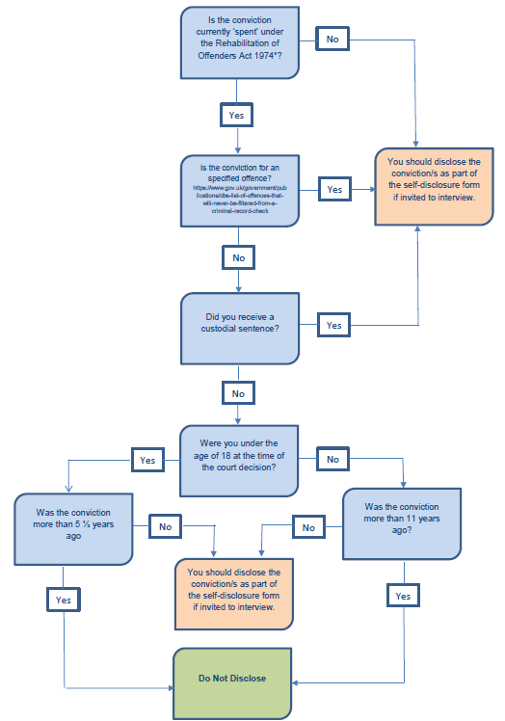

**Disclosure of a Caution - Please work this through for each caution you have separately** (this includes reprimands and final warnings)

