

***Embed confidence; fuel ambition.***

**Essential information for parents and carers**

**2025 - 2026**

**Welcome to Lawnswood School**

This booklet is designed to provide you with all the information you will require to help your child settle into life at Lawnswood School. Please note that information included is accurate at the time of printing – sometimes, we may make changes according to circumstances. If this is the case, we will share those with you in advance of your child starting in September.

After reading this booklet, if you require any further information please don't hesitate to contact us using the number below.

**School telephone number: 0113 284 4020**

**School website:** **www.lawnswoodschool.co.uk**

**To see a snapshot of daily learning, please visit our school twitter page: @lawnswoodschool**

**Your role as a parent / carer**

In order to support your child’s education effectively, we ask that you:

* ensure your child is prepared for each school day by having the right books and equipment and gets a good night’s sleep
* ensure your child is on time for school and therefore doesn’t miss any learning time
* ensure your child attends school every day and inform us if they are too unwell to attend
* ensure your child attends in the correct uniform
* check the student learning toolkit daily if possible and sign it weekly to show us that you are aware of the content
* check Class Charts daily so that you are aware of home learning, commendations, cautions and consequences
* at the end of each day, ask your child what he/she has *learnt* (not just what he/she has done)
* set aside time during the evening to allow your child to complete their home learning
* ensure your child has somewhere quiet to complete their home learning
* check your child has completed their home learning
* reassure your child that we are all here to help and want students to be happy and succeed at Lawnswood School
* contact us if you or your child has any concerns.

**How do we let you know how your child is progressing?**

You can talk to staff at any time about your child’s progress at school, but we will send you a progress report three times a year. We have parent consultation evenings where you can meet your child’s form tutor and individual subject teachers. Consultation evenings usually begin at 4.30pm and end by 7.00pm, but the times will be confirmed closer to the date. The booking system for the parent consultation evenings will be available on our website. These may be a combination of in person and virtual meetings.

**Let us Know**

You will find additional contact information at the back of this booklet. We strongly encourage you to keep in contact with the school if you have any concerns at all. Working in close partnership with parents is very important to us, so please never hesitate to ask any questions or seek support if needed.

**The school day**

**Timings of the School Day**

**Start and finish times**

|  |  |  |  |
| --- | --- | --- | --- |
| **Key Stage** | **Arrive at School** | **Leave School** | **Tutor Period** |
| 3 & 5 | 8.20 | 14.50 | 8.30-8.50 |
| 4 | 8.20 | 14.55 | 8.30-8.50 |

We review the timings of lessons and breaks annually: we will share the specific lesson, break and lunchtimes with you in advance of starting in September.

**Access to school**

We have pedestrian access gates on Spen Road and Otley Road.

Pedestrian gate open times:

Spen Road 7.00am to 8.45am

2.30pm to 6.00pm

Weetwood Road 8.10am until 8.20am and 2.50pm - 3.00pm

* Students attending breakfast club will be supervised from 8.00am. Breakfast club is open to **all** students and is accessed via the entrance to the diner near main reception.   Other students will be supervised from 8.20am, once on the school grounds, and supervision will continue until 2.50pm, or later if the child is attending a pre-agreed, supervised school club or activity with member(s) of staff.  Clubs and activities finish at different times so the time our supervision will end will coincide with the finish time of the club or activity.
* The school cannot be responsible for the supervision of students or parents outside the times described above and we will not accept liability for injury outside the supervision times stated.
* To ensure the safety of our students, **we ask that parents, carers and friends do not drive onto the school site to drop off or pick up students at the beginning or end of the school day**.  If you are dropping off or picking up a child, please do so in the surrounding streets where it is safe to do so.

**End of day exits**

We are a large school site with two main *student* exits – it’s important that you and your child familiarise yourself with these and are clear about meeting points, e.g. if you arrange to meet your child at the end of the day, so as to avoid any delay. **Students are not allowed to leave via the main school gates on Otley Road.**

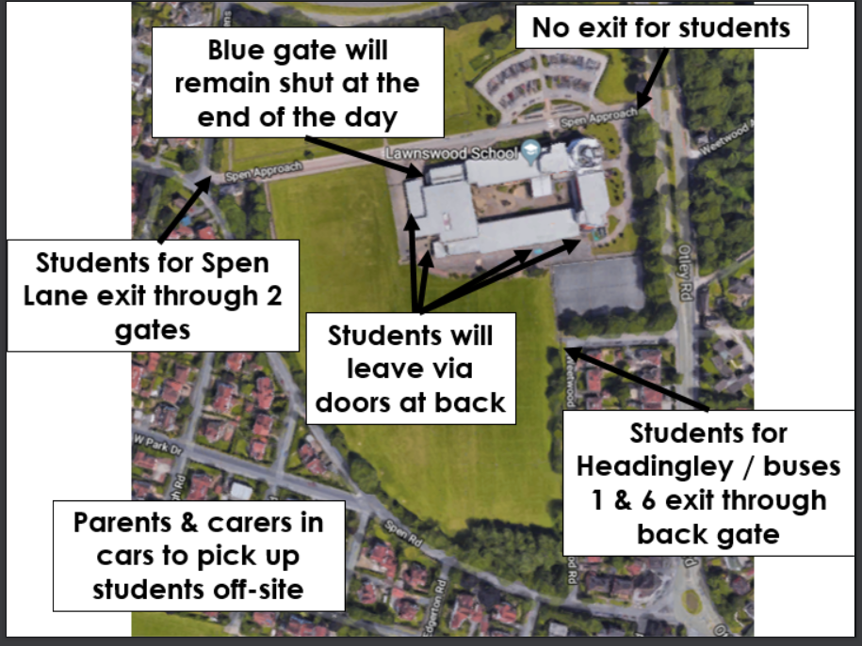

**Cycling to School**

The school cannot take responsibility for bicycles on its premises. Bicycles are brought at the owner’s own risk. **Equipment for school**

**Lawnswood School has an expectation** that all students have the following equipment at all times:

* An A3 size, strong, waterproof bag, big enough to carry several books
* Learning toolkit (student planner/diary)
* A pencil case containing at least three black pens, a green pen, a purple pen, three pencils, a pencil sharpener and an eraser
* A 30cm ruler
* A scientific calculator (Casio fx-85GT PLUS)
* A reading book.

**We also recommend:**

* A glue stick
* Coloured pencils
* A small geometry set containing a protractor and compass
* A small dictionary and thesaurus.

Note that we do not allow Tipp-ex products in school.

Some days, according to the timetable, your child will also need to bring their **PE/Sports kit** which is detailed below.

* Lawnswood long sleeved rugby jersey (optional)
* Lawnswood long sleeved ¼ zip sports jumper (optional)
* Lawnswood Red PE top

Either the rugby jersey or ¼ zip top is recommended for colder days to layer over the standard short sleeved PE top.

* Black tracksuit bottoms, full length leggings or shorts
* Red and black socks
* Trainers for indoor and summer activities
* Studded boots suitable for outdoor football, rugby and other activities (some astroturf boots are also suitable for outdoor activities)

It is good practice for students to pack their bag the night before school using their timetable to ensure they are equipped with everything they need for the next day, including home learning. Initially, this is something that parents and carers can help with.

**Student learning toolkit**

Your child will be given a learning toolkit at the beginning of each school year. Students are expected to take care of their planner, have it with them every day at school and use it daily to help them manage their time and work. Replacement planners cost £4.00 and are available from the school shop located in G44.1, at break time.

The planner is an important part of home-school communication and you can use it to follow your child’s progress at school and to write notes to their Form Tutor or subject teachers. With this in mind, we ask that you sign your child’s planner each week to indicate that you have read the recent entries.

**Pride in our Community - School Uniform**

One of the ways we can ensure that our students are respected in the local and wider Leeds community is by encouraging them to dress appropriately for the school environment. We need parents and carers to reinforce the need to maintain standards of dress for Lawnswood School students. Correct uniform is at the discretion of the school.

**All students must wear:**

* Black blazer with embroidered school badge. Students must wear blazers at all times. It is not acceptable for students to keep their blazers in their school bags.
* Formal **white** shirt, with stiff collar, tucked inside trousers/skirt.
* Correct school tie with a black stripe.
* Formal **black** school trousers or school skirt.
* formal school trousers means no jeans, no tracksuit bottoms, no skin tight trousers or leggings, no combat trousers.
* formal, conventional, school skirt means length is just above the knee; the length of the skirt must be decent for the safeguarding of all our pupils.
* Sensible formal **black** leather (or equivalent) school shoes with **black** laces: entirely black, no boots, no stiletto heels, no shoes without backs, no leather trainers, no logo of any kind. Dark socks or plain tights in flesh/black tones should be worn.
* The V neck school jumper (grey for KS3 and black for KS4) is **optional** and is **not** an alternative to wearing the school blazer.
* During warm weather, we advise pupils not to bring their jumper to school.
* Coats, sweatshirts, hooded garments, hats, gloves, scarves and any other accessories must not be worn inside the school. If seen, they will be confiscated and passed on to the student’s Year Manager for return at the end of the school week.

**Reminders:**

Students should avoid extremes of personal appearance. This includes hair colouring and haircuts. All extreme hairstyles are at the discretion of the Headteacher.

No excessive jewellery or make up is allowed. One small necklace, one ring, one bracelet, one pair of stud earrings is acceptable.

**No facial piercings** are allowed for safety reasons.

**Mobile phones, iPods, other musical devices and headphones/ear pods will be confiscated if seen during the school day: this includes during lesson time, on corridors during lesson transitions and social times.**

Your child is expected to wear full school uniform at all times in school, with the tie up to the collar, and plain black formal shoes. Students who come to school without the correct uniform will be removed from circulation for the day. We will contact you to ask for your child to go home to change, or for you to bring the correct item of uniform into school. Please remember to label everything clearly with your child’s name.

**Buying school uniform**

**We have two authorised suppliers of our uniform:**

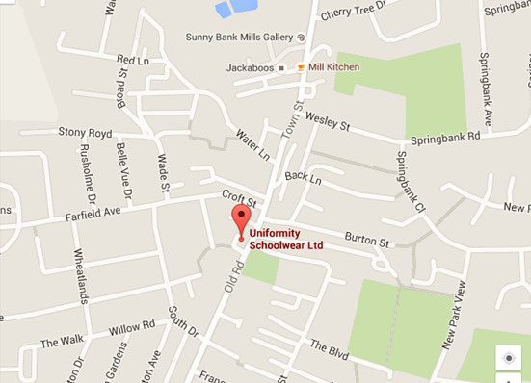

Whittakers Schoolwear

3/5 Town Street

Farsley

Leeds

LS28 5EN

Telephone: 0113 256 6020

www.whittakerschoolwear.co.uk

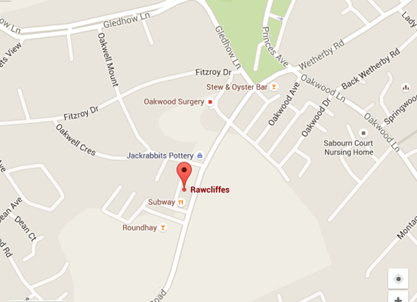

Rawcliffes Schoolwear

617 Roundhay Road

Leeds

LS8 4AR

0113 2494025

email: leedsrawcliffes@gmail.com

www.schoolwearsolutions.com

**Both suppliers offer a free delivery service to school.**

If you need support purchasing uniform, the uniform grant application can be found here: <https://www.lawnswoodschool.co.uk/for-parents-and-carers/primary-transition/uniform-grant-application>

**We also operate a ‘pay as you feel’ uniform exchange - this will be open at the parent information evening in July. We do recommend leaving it until the summer term to purchase to account for growth!**

**Autumn Term Dates 2025 – 2026**

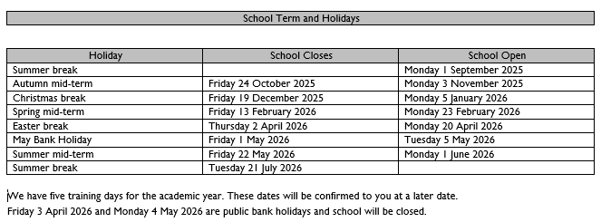

**Attendance Policy for Years 7 to 13**

**General statement of aims:**

* Lawnswood School seeks to ensure that all its students receive a full-time education which maximises opportunities for each student to realise their true potential. Good attendance leads to high attainment.
* The school will encourage attendance by providing a welcoming, caring environment, wherein each member of the school community feels wanted and secure. The school’s curriculum policy identifies ways in which the curriculum and teaching and learning together also encourages good attendance.
* All school staff will work with students and their families to help ensure each student attends school regularly and punctually. Responsibility for attendance is shared by all school staff in their various roles, pastoral or otherwise.
* The school will maintain an effective system of incentives and rewards such as a film afternoon and trip opportunities. These acknowledge the success and efforts of students to improve their attendance and timekeeping and will challenge the behaviour of those students and parents who give low priority to attendance and punctuality.

To meet these objectives, Lawnswood School will maintain an effective and efficient system of communication with students, parents and appropriate agencies to provide mutual information, advice and support.

**Attendance**

All pupils are expected to attend school daily except in cases of illness or circumstances previously condoned by the school (e.g. hospital appointment, funeral). Please contact your child’s Year Manager in advance.

If students are ill, parents must phone school to explain their child’s absence on the first day of absence, with the reason for absence and expected date of return. All illnesses should be specified; “ill” does not suffice - the nature of the illness must be given in order for the absence to be approved by the school.

**Punctuality**

All students must arrive on time to morning school (8.25am for a prompt start to registration at 8.30am) and to each lesson throughout the day. If a student is late (with no unavoidable reason) they will sit a 30-minute detention after school on the same day.

**Attendance – a shared responsibility**

**The school will:**

* reward good attendance and punctuality;
* intervene when poor attendance/punctuality becomes a problem and before it becomes a habit;
* deal sympathetically with any problem a student may have which is causing attendance / punctuality to decline and always stay in regular contact with parents;
* recognise the needs of individual students when reintegrating them into school after a significant period of absence;
* automatically involve other agencies when all other intervention has failed; and
* automatically involve other agencies when parents take their children on unauthorised holidays during school time.

**Parents/Carers will:**

* encourage their children to attend school daily and be punctual and inform the school immediately if their child is absent or unavoidably late;
* inform the school in advance (via phone call or planner) of any hospital appointment unavoidably scheduled during school time;
* inform the school of any problems which might affect their child’s attendance; and
* co-operate with the school if their child’s attendance/punctuality is unsatisfactory.

**Students will:**

* always attend school unless prevented by a specified illness or unavoidable circumstances; and
* always arrive to school and lessons on time.

**Behaviour expectations and consequences**

At Lawnswood School we believe that students make the best progress in a calm learning environment. We have clear systems in place to ensure that we achieve an environment which is conducive to learning. Students are expected to meet our expectations at all times.

**Expectations in the classroom**

* Arrive on time for the start of the lesson—fully equipped and read to learn
* Wear correct full school uniform at all times unless directed by the teacher
* Follow the school and specific classroom routines/seating plan
* Respond promptly to the signal for attention
* Listen in silence when others are speaking
* Follow instructions from teaching staff when they are given
* Have full equipment for learning positioned on the desk
* Focus fully on work and do nothing that prevents others from learning
* No mobile phones, music players and headphones

**Expectations in the corridors**

* Wear correct full school uniform at all times
* Coats should be carried, not worn
* Walk purposefully, on the left, without running
* Use indoor voices
* Follow the instructions of all members of staff
* Do not eat, drink or chew
* Don’t have unnecessary physical contact with other students
* Do not disturb other classrooms
* Put litter in bins
* No mobile phones, music players and headphones

**Expectations in social spaces**

* Wear correct full school uniform at all times
* Ensure coats are carried and not worn if inside buildings
* Walk purposefully without shouting
* Follow the instructions of all members of staff
* Do not eat, drink or chew inside the buildings other than in designated areas
* Don’t have unnecessary physical contact with other students
* Put litter in bins
* No mobile phones, music players and headphones

 If students fail to meet our expectations then we have clear consequences in place and students will be reminded of the importance of following these rules.

Support programmes are in place for students who receive a large number of consequences. To read our full Behaviour Policy, please visit the website.

**Our current Behaviour and Relationships Policy can be viewed in full on the school website and we recommend you take time to read it carefully in advance of students’ starting in September.**

<https://www.lawnswoodschool.co.uk/key-information/our-policies>

To record commendations and consequences staff use Class Charts. As a school we utilise this system to reward and monitor our students. As a parent, you will soon receive a unique code so that you can download the Class Charts App and access your child’s profile, including any commendations, consequences or reflections. Class Charts is an essential part of our communication with you, so please do make sure you set up your account when you receive the information in the summer.

**Automated recognition systems**

Our school library and diner operate with automated biometric recognition systems.

The software we use turns your child’s fingerprint image into a mathematical algorithm. The fingertip image is then discarded. The information stored cannot be used to re-create an image at any stage.

The easiest way to load money to your child’s account is via **ParentPay**, for which you’ll soon receive registration details. This means you can add money online, without your child having to bring cash to school; however, if you choose not to do this, we do still have two loading machines next to the KS3 Diner, where children can add money to their accounts.

Any amount of money can be paid into your account and is held within the system. Money spent on food will be taken out of your child’s account and your child can always check to see how much is left by using any of the cash loaders in school.

You can set a daily ‘spend limit’ which is currently £5.00 but this can be increased or decreased for an individual pupil by making a written request via The School Office, who will inform the Diner about changes.

In order to use the image of your child’s fingerprint to create a mathematical algorithm, with which to identify your child’s accounts, we need the written permission of one parent/carer. For that reason, please complete and sign the consent form even if you do not give consent. You have a right to withdraw consent in the future. If you do so, we shall arrange for your child to access the diner and library facilities by other means.

**Food and drink during the day**

The school catering service, provided by Chartwells, offers a full meal provision starting with breakfast from 8.15am to 8.30am where students can buy toast and bacon sandwiches. At break and lunch times, a balanced and wide range of food is available. You should expect a lunch to cost approximately £2.50. Children entitled to Free School Meals will have their accounts automatically credited by the school, once information has been received regarding eligibility. All students are welcome to bring a packed lunch and to eat it in the Diner. There are drinking water fountains near the Diner and PE. Except water, students are not allowed to drink or eat during lessons or in corridors.

If you ever need information about your child’s use of the catering service, please contact his/her Year Manager, who will be able to provide a detailed report, such as items of food served as well as each credit made to the system and a current balance of your child’s account.

Students are not allowed off site at lunchtime. If you want your child to come home for lunch, please seek permission by letter from the Year Manager, who will give your child a lunchtime pass. If your child is late back after lunch, permission may be withdrawn.

**Impact Cashless Catering Biometrics Overview**

**What is a cashless system?**

At the heart of the cashless system there is a computer controlled by ***I.M.P.A.C.T*** software.

***I****nformation—****M****anagement for–* ***P****oint of sale—****A****ccess and—****C****ashless—****T****racking*



This allows the system to recognise each individual pupil, hold individual cash balances, record cash spent and cash received and record where money is spent, on what food, on any specific date and time of day.

|  |  |
| --- | --- |
| **How are pupils recognised on the system?**  Each pupil will have a digital image of their finger taken which will then be translated to an Alpha numeric number. The image is then discarded. When used, this will enter the pupil into the system program and identify them by a number.  **How is this used to obtain a school meal?**  The pupil simply places their finger on a  scanner at the point of sale; a display will show the server the pupil’s name, class and current cash balance held within the system. The selected food items will be entered into the system from an itemised keyboard while the amount spent and the new cash balance will show on the display.  **How is money entered into the system?**  **For topping up accounts –** by **ParentPay** or  by ‘Cash Note and Coin’ into an automatic cash loader machine located in the school near the diner which is set to accept £20, £10 and £5 notes and £2, £1, 50p, 20p and 10p coins. (1p, 2p and 5p coins cannot be used). | **How does the loader machine work?**  The pupil places their finger on the biometric scanner mounted on the cash loader machine to enter the I.M.P.A.C.T system. The machine will display the pupil’s name and current cash balance held within the system. Then coins are inserted into the slot.  **How will the pupil be able to check what current cash balance is held in the system at any one time?**  **By using the cash loader machine.** Place their finger on the scanner to display the current cash balance. There is no need to deposit any money, just press the red button to finish.  **Also, a remote display** at the point of sale in the dining room will show the new cash balance when the food service is finished.  **If we pay for a set number of school meals, can it be spent in one day?**  No, a daily spend limit of £5.00 will be set for all pupils and no food above that limit can be bought. On written request to school, an individual pupil limit of your choice could also be set, to include a school lunch and break time snacks**.** |
| **Frequently Asked Questions**  Q. Can digital finger images be used by any other agency?  A.  No. The software we use turns your child’s finger image into a mathematical algorithm. The image of the digital image is then discarded. The information stored cannot be used to re-create an image at any stage.  Q. What happens when a child leaves school?  A. When a pupil leaves our school, all data will be deleted. | |

**Medicines in School**

**First aid, medical and health or safety** – you can ring your child’s Year Managerif you have specific medical issues you wish to discuss or inform us about.

As part of accepted good practice and with advice from the Department for Education, relevant voluntary organisations and the school’s governing body, we have recently updated our guidance on medications in school. We ask all parents to read our Health and Safety Policy, which is available upon request from school and is also on the school website. If you have any questions or concerns about the policy or any medical supervision queries, please do not hesitate to contact Student Reception.

Please ensure that we are kept up to date with your child’s health details i.e. any medical condition, current medication, symptoms and emergency contact numbers. It is also vital that we are aware if your child is allergic to anything which he/she may come into contact with at school, e.g. wood dust, flour or any ingredients which they may use in lessons. This will help the school to better understand and cater for your child’s individual needs.

If your child needs to take any medication in school, we must know about it beforehand and we will need you to sign an authorisation form, so please ring your child’s Year Manager to arrange the relevant documentation. This also includes EpiPens, insulin and inhalers, which are the only medications we currently allow students to carry in school. In the case of these, we strongly recommend that spare EpiPens, insulin and inhalers are kept in the medical room in case of need. **Any medicines sent into school must be in their original container, with your child’s name on, as dispensed by the pharmacy. The pharmacy label stating the child’s name, the name of the medicine, the dose and the frequency of administration must be clearly visible**.

New guidance dictates that Paracetamol is the only non-prescription medicine allowed in school and this is the only medication, other than the items detailed above, we allow pupils to carry with them for their own personal use. **This requires a form completing to seek permission for your child to carry sufficient for each day’s use.** This request will be reviewed and approved by the Headteacher.

Where it is felt that a child with a medical condition requires a Health Care plan, parents will be contacted by a member of the Year team to assist with the completion of this.

Please remember that not having up to date information about your child’s medical condition could affect his/her participation in certain activities in and out of school and may put their health at risk. Please note that, in the absence of clear guidance from a medical professional, Lawnswood School staff will not make clinical decisions unless in extreme circumstances.

**Use of students’ images in photograph and film**

During your son/daughter’s time at Lawnswood School, we often wish to take photographs and/or video of students participating in classes, courses or other activities within the school or offsite. Occasionally, we may wish to allow the use of images by providers with whom we are working closely and whose activities and staff are appropriately screened and authorised (e.g. external deliverers of a skills programme; organisations leading activities as part of the curriculum or engagement programme). Also, from time to time, our school may be visited by media who will take photographs or film footage such as during a high-profile event or a dignitary’s visit.

It is wonderful to be able to celebrate the achievements of our students by placing photos on the school’s website, school’s twitter account or in the local media. Any such recordings or photography is, of course, always supervised by a member of staff and is carefully regulated by the school.

All data will be held, processed and stored according to Leeds City Council’s data protection policy and procedure.

We will not use the personal details, other than first name and surname, of any child or adult in the photograph or video on our website or printed publication, nor will we provide approved external users of photographs or video with personal details, other than first name and surname.

We may use group or class photographs or footage with general labels, such as ‘a history lesson’.

We will only use images of students who are suitably dressed.

We may include pictures of students and staff that have been drawn by students.

If you wish to withdraw your consent at any time, please contact your child’s Year Manager.

**Physical activities on and offsite including fixtures**

Lawnswood School is fully committed to ensuring every child receives their entitlement of physical activity in line with government recommendations. We also are committed to helping students to fulfil their potential, in a range of high-quality activities, under expert instruction. This includes activities which take place during lessons, lunchtime activities and after school clubs. All our sporting activities are carried out in line with the guidance provided by “Safe practice in Physical Education and School Sport” and the national governing bodies of each sporting activity. During the year, we will also provide your child with opportunities to try out new sporting activities such as our climbing wall and weights / fitness room. No student will be asked to do anything that is unsuitable or inappropriate for their age or ability and all guidance will be provided by qualified staff.

**PE clothing and footwear**

Please ensure you send your child with the correct kit to enable him/her to participate in the sport safely. If a student does not come to school with the appropriate kit for the activity being undertaken, the student will not be able to fully take part and will have to undertake a modified activity. As the school is fully committed to ensuring all students get their full statutory hours of physical activity, we will take action where any student regularly fails to bring the correct kit. You will be contacted and may be asked to come into school for a meeting to discuss this further. We will apply sanctions to students who fail to bring in the correct kit.

Please ensure that we have up to date contact details and medical information about your child.

In the event of a serious injury, needing hospital treatment, you will be contacted as soon as possible by the relevant staff member and given all the relevant facts. Our priority will always be to get treatment for the child. For minor injuries, an appropriate person in school will administer first aid treatment or, in the case of away fixtures, the student will be brought back to school with the team. All our PE staff have been fully trained in First Aid by a HSE approved training organisation.

You should be aware that, occasionally, coaches are brought into school for specialised activities.

All coaches have full Disclosure and Barring Service clearance to work with the children or are fully accompanied by a member of school staff.

**Sports Teams**

We realise that for many students being part of a team is an important aspect of their school life. During your child’s time at Lawnswood School they may be selected to represent the school in a sporting activity as part of a team. As such, they will be given opportunities throughout the year to participate in various matches/tournaments/events and occasionally these may occur at short notice, e.g. if a team member drops out, etc.

It is highly likely that students will, at some point, have to miss their normal timetabled lessons to participate in some sporting events. For this reason, it is important that the student understands that their behaviour in lessons can influence their place on the team. They should be aware that failure to hand in homework on time may result in a temporary suspension from the team or that the class teacher will not give the student permission to miss their lesson.

Students are the responsibility of their parent/carer once they have left the school premises after any fixture / after school activity or trip. Unless you tell us otherwise, we will allow your child to leave the premises after any fixture or trip to make their own way home.

You should be aware that, occasionally, only the group leader may be present on the minibus for local away fixtures and that this person is commonly also the driver. For fixtures away from school involving transportation, students are expected to remain seated with their seat belts fastened and to behave sensibly at all times.

There are occasions when students ask us to drop them off at a convenient point nearer to their home on the homeward journey. This may be possible, if convenient, but only with written permission from parents in their planner. However, you should be aware that, from the point at which we drop off the student, you must accept full responsibility for your son/daughter’s wellbeing.

We appreciate how frustrating it can be for you when fixtures and matches have been cancelled at the last minute because of weather conditions or staffing problems, and we apologise for any inconvenience in advance. When matches are cancelled, we do try to rearrange them as soon as possible and students are made aware of the new date. This will be communicated via Squad in Touch.

We hope your child enjoys the sporting activities and fixtures during their time at Lawnswood School. We are happy to discuss any individual queries you may have. Risk assessments are available upon request for these activities. Please request a copy from the main school office.

**Offsite visits consents in the local area**

By signing the local visit consent form you are agreeing to your child going on trips within the school day in the local area i.e. walking to Weetwood to collect nature samples or walking to sports day at Leeds Beckett sports venue. This will allow us to take your child out of school using the medical information we hold on our system. You will be notified when a visit/trip such as this takes place.

For visits further away we will advise you in writing and may also send an E1 medical consent form for you to complete.

**Please complete and sign the consent form. Please note that without this consent form and your agreement to its terms, we will be unable to allow your child to participate in any offsite sports fixtures or visits**.

**Instrumental and Vocal tuition**

At Lawnswood School, we believe that music tuition can be a very valuable addition to a student’s education, not only for the obvious musical reasons but also for the many benefits and experiences that the learning of an instrument brings, such as teamwork, creativity, perseverance and simple good fun.

In partnership with ArtForms and other music professionals, we are pleased to offer our students an extensive programme of instrument tuition in brass, woodwind, guitar, percussion, keyboard and voice. Tuition for these instruments is approximately £80 per term. Our finance staff will send parents/carers an invoice at the beginning of each term, which can be paid by cash or cheque, payable to Lawnswood School.

If your family receives income support, it is likely that you will not be expected to pay for the tuition.

To check your eligibility for free tuition, please contact Mrs Rushton in the music department.

Students will be required to:

* Provide their own instrument (except drum kit)
* Purchase their own music
* Pay the costs of any entry into an exam

Lessons are generally provided during the school day which means that students will miss sections of their curriculum in order to attend their instrument lesson and this will be on rota basis. Demand for tuition is high and it is not always possible to offer lessons to all students who apply. A letter and invoice will be issued if your son/daughter has been successful, or you will be notified and placed on a waiting list if they are unsuccessful.

**Instruments**

Children who have been learning for some years before getting to Lawnswood School often have their own instrument. However, if you are a beginner or don’t own an instrument, we can offer the following:

For absolute beginners, we can recommend schemes that enable you to hire an instrument for a trial period while you decide whether or not you like it.

ArtForms (part of Leeds City Council) runs an instrument rent-and-buy scheme. The instruments they supply are priced significantly below expected retail prices. Music department staff can tell you more about the scheme or you can find out more from ArtForms on 0113 247 5499.

**Making progress**

A combination of good attendance and frequent practice is crucial for you to make the best progress. We monitor progress in the following ways:

* Peripatetic teachers keep attendance registers, which are monitored by us in the department
* Students are expected to tell their teacher in advance if they’re unable to attend a lesson. If you persistently miss lessons, we will write to parents and cancel your instrument lessons.
* Every student is given a practice diary in which to record their work and a log of practice. We ask parents to sign the log to confirm how much practice has been done. We reward students for good practice.
* We write a progress report once a year and send it home during summer term.

Students are normally taught in small groups or individually, depending on progress and the level of demand. Students receive up to 33 lessons a year. Tuition takes place during the school day and on a rota basis. We expect students to excuse themselves from normal timetabled lessons in order to attend their instrument lessons. The accepted arrangement is that students shouldn’t miss more than a single timetabled lesson per month in any particular subject. Some lessons may be during morning break or lunchtime.

On the day of your instrument lesson:

* Leave your instrument on the shelves in room F46 (ensemble room) before the start of school – you can access the room from 8.15am until 8.30am.
* Check the noticeboard outside F47 (the music office) to find the time of your lesson – ask if you need help with this!
* Ask permission from your subject teacher if you need to miss a timetabled lesson. Use a permission slip – they’re available in F47.
* Attend your instrument lesson at the right time. Let your teacher or music staff know if there are problems.
* Collect your instrument from F46 at the end of the school day.
* Make sure your instrument is covered under your home’s insurance policy and clearly labelled with your name, form group and home address.

Every student who plays an instrument is expected to support the school’s positive musical ethos by participating in at least one extracurricular music event during the year.

We also invite you to join one of the school’s musical ensembles, which meet regularly.

**How to enrol**

If you would like music lessons, please contact Mrs Rushton in the music department for a consent form.

If we can offer you lessons as requested, we will notify you when your child starts school and will send an invoice.

If we can’t offer lessons as requested because they are currently oversubscribed, we will put your name on a waiting list until an opening arises.

**Instrumental and Vocal tuition**

**Terms and Conditions**

**Payment**

The contract you are entering into is for instrumental or vocal tuition for the whole year, three terms: September, January and April. (autumn, spring and summer)

The cost is approximately £80.00 per term or approximately £240.00 for the whole year.

Parents / Carers can make one payment for the whole year or termly at the start of each term by cash or cheque. Cheques should be made payable to Lawnswood School and have your child’s name, form, and instrument written on the back.

**Timetable**

Students must check the times of their lessons with the peripatetic tutor and attend promptly.

Students should check the notice board in the music department each week for alterations of lessons, tutor absences.

**Curriculum classes**

Instrument lessons will overlap with normal classes.

Students are responsible for copying up any work missed and check for homework.

**Attendance**

Students will maintain a high attendance record and must notify the head of the music department, or their instrument tutor of any absence.

A letter will be sent home if attendance becomes unacceptable and improvement is needed.

**Practice**

Students must practice regularly between music lessons. Progress will be assessed.

**Extracurricular**

It is very much hoped that students will contribute to the musical life of the school by playing in at least one band/ensemble.

**Ending tuition**

Parents / Carers must inform the school in writing of any intention to withdraw from tuition.

Address your letter for attention of The Finance Team, main school office, G02.

Please remember that you are entering into a contract to pay for a full term of tuition.

**Additional Information**

**Home learning**

We promote independent working beyond the classroom to support classroom learning and to help students develop skills they need for successful lifelong learning. You will see notes about home learning tasks recorded by your child in their learning toolkit; however, detailed information and resources are also recorded on Class Charts.

Tasks might include research, reading, extended writing, model making etc. and may be set over a number of weeks. Please encourage your child to complete tasks and to develop independent learning skills.

In order to study or completed home learning after school, with support from staff, all students are welcome to study in the Library from 2.45pm until 4.00pm, Monday to Thursday and 2.45pm till 3.30pm on Friday.

**Enrichment**

We offer a huge range of extracurricular activities, both at breaks and after school. The activities include sports, performing arts, creative, academic-linked, community and enterprise. We expect students to take part in at least one extracurricular activity a week and ask that you will encourage your child to participate as widely as possible.

**Mobile phones**

We allow students to bring their mobile telephones to school, but they should not be seen or heard in the school building and should be switched off until the exit the building at 14.45. If your child’s phone, earphones or other electronic equipment is visible in school, we confiscate it and the student can collect it at the end of the school day. A caution will be issued each time, which may lead to an after school reflection. If you need to contact your child during the school day, please do so through the office or student reception. Alerts from parents/carers can cause unnecessary worry for children, so please avoid contacting them on mobile devices during the day.

The school accepts no liability for any phone or other equipment that is lost or stolen because the student has not followed the procedures put in place to ensure safe keeping. **The school will not investigate a lost phone.**

**Social Media/WhatsApp**

Please be aware of your child’s engagement with social media, such as Snapchat, TikTok, Facebook, Instagram and Twitter. Take time to discuss with them how to keep themselves safe online; page 13 of the learning toolkit provides some advice from [www.kidscape.org.uk](http://www.kidscape.org.uk). Messaging that takes place on social media and online at home can sometimes arise in conflict that spills into school, taking up considerable pastoral time and resources. Whilst we will support serious incidents, it is not our responsibility to manage or monitor students’ phone use out of school.

**Friends of Lawnswood**

Lawnswood School has a flourishing partnership with the Friends of Lawnswood (FoL). The group is involved with events throughout the year and is very keen to support parents and to help them get involved in the wider life of the school. There are groups within FoL that focus on different activities, such as art and design, badminton, social events and a community choir. You will find more information about Friends of Lawnswood by clicking their icon on the home page of the school website. Their email address is friendsoflawnswood@hotmail.com

**Correspondence by email**

With a view to communicating with parents and carers more efficiently, we will be sending some of our correspondence to you by email instead of letter. This would not include documents that need printing by you but it might include, for example, letters from the Headteacher, updating you on various school matters. In accordance with Data Protection, letters sent by email will be non-specific and will not include any personal data. If you change your email address, please let us know, so we can update our records and enable you to receive our correspondence.

**The Alan Bennett Library**

The Library is located on the second floor of the building. Students have access to the information resources and services in the Library daily from 8.00am to 4.00pm except Friday when the library closes at 3.30pm. Students may borrow up to 2 books which are issued for three weeks and these may be renewed up to three times. The Library also has a collection of DVDs which may be borrowed for three days. All items are issued by using a fingerprint scanner. During the lunch break, students are able to use the computers for a 15 minute session which is booked at the library desk.

The Library stocks both fiction and non-fiction resources which support the curriculum and Mrs South the librarian is available to help with student enquiries. The Library provides students with themed reading lists and ‘reading for pleasure’ is a key focus and throughout the school year there are reading activities and competitions aimed at improving literacy. The Library also holds a selection of e-resources which may be accessed anywhere in school or from home via the library management system Eclipse.

**English as an Additional Language (EAL)**

We have an EAL Coordinator to support pupils and families who speak languages other than English. Please contact Anna Mason if wish to discuss supporting your child in school. If you need help completing any forms, want further information or need translation help, contact Anna on the school telephone number or by email at anna.mason@elawnswood.co.uk.

**Who to contact**

**Form tutor**

Every day your child will have time with his/her form tutor. Form tutors are a good point of contact for everyday issues or messages. You are welcome to email your child’s tutor; he/she will give you an email address at the beginning of the school year. Form tutors are also teachers with timetable commitments, so they will have limited times when they can contact you by telephone. However, they will aim to get back to you within 24 hours of receiving your message or reading your email.

**Year Manager**

A Year Manager’s responsibilities include:

* dealing with day-to-day pastoral issues (e.g. wellbeing)
* monitoring attendance, punctuality and behaviour and applying the appropriate school policy
* organising any necessary support for students
* developing and maintaining good communication with parents and carers
* uniform issues
* child protection

**Head of Year**

Heads of Year work with Year Managers to oversee academic progress and pastoral concerns such as personal or family issues that may impact on wellbeing or progress. Heads of Year are also teachers with timetable commitments - this means they have limited or specific times when they can contact you. However, they will aim to get back to you within 24 hours of receiving your message or reading an email.

**Subject Leaders** - for specific questions or concerns about particular subjects.

As teachers are in lessons most of the day, you are welcome to email staff, so that they can ring or email you back as soon as possible. Email addresses for subject leaders are on the school website.

**Student reception** – contact via 0113 284 4022

The Student reception team can help you if you need to:

* report your child absent for any reason
* inform us if your child will be late
* arrange to collect your child from school or deliver them to school outside normally expected times
* drop items into school for your child during the school day or get a message to your child during the school day

**Visitor reception** – 0113 284 4020

**Note**: Staff in school may also contact you directly if they have any concerns about your child’s learning, attitude, general wellbeing or behaviour. We will use the telephone and/or email details you give to us, so it is important that you keep us up to date if any contact details change.

**If you wish to meet a member of staff please ensure that you make an appointment. Due to staff timetables and meeting commitments, it will not always be possible for you to see the member of staff you wish to see simply by dropping in.**

**Parents’ Notes**