Food and nutrition
Recipe book
Hello Year 6
I thought you might like to try some of these recipe ideas before you come to Lawnswood
I can’t wait to meet you all. Take care and stay safe Mrs Ellis
Bread based pizza
Ingredients:
200g Strong Plain Flour
25g Margarine
1 sachet dried yeast / Pinch salt
125ml warm water 100g cheese
100g tomato puree / sauce
Choice of toppings/flavourings such as:
Ham, olives, red onion, pepper, cooked chicken, sweet corn, mushrooms, cooked bacon, mozzarella, salami, mixed herbs

Equipment:
Green chopping board, baking tray, measuring jug, table knife, sharp knife, grater, mixing bowl, rolling pin, flour dredger, container

Method:
- Wash hands and put on apron.
- Check oven is on – GM 6 / 200 C. Grease baking tray.
- Get all ingredients (toppings chopped/grated etc.) and equipment.
- Place flour and salt in a mixing bowl, add margarine and rub in with fingertips.
- Add dried yeast and mix with table knife.
- Measure 125ml warm water into measuring jug. Add the water a little at a time, mixing with a table knife. It shouldn’t be sticky but should have no dry floury bits.
- Sprinkle flour onto work surface and knead the dough for approx. 5 minutes. *add herbs and flavourings here*
- For pizza whirls: Roll out a rectangle approx. 30x25cm and spread tomato puree to the edges.
- Add the cheese and toppings and roll into a sausage shape, then gently seal the edges.
- Using a sharp knife cut into 2-3cm pieces.
- Lay flat on baking tray and bake for 15-20 minutes.
- For Pizza: Roll out dough into shape required and lift onto greased baking tray.
- Spread tomato puree, add cheese and toppings.
- Bake for 10-15 minutes

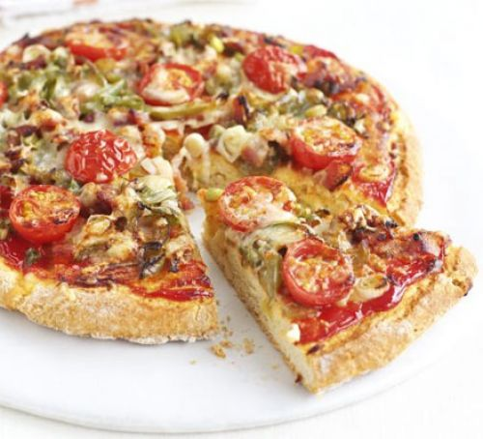
Scone based pizza
Ingredients:
200g Self Raising Flour
50g butter
100ml milk
100g tomato puree / sauce
75g grated cheese
Topping ideas:
Pepper, cooked chicken, salami, red onion, olives, mushrooms, mozzarella, sweet corn
Equipment:
Green chopping board, sharp knife, measuring jug, rolling pin, mixing bowl, baking tray, round bladed knife, grater, flour dredger

Method:
- Wash hands and put apron on.
- Pre-heat oven – GM 6 / 200C. Grease a baking tray
- Get all ingredients (all toppings chopped/grated etc.) and equipment ready.
- Place flour and butter into a large mixing bowl, run with fingertips until it looks dry like sand.
- Add milk gradually, stir with a knife every time until it forms a soft but not sticky dough – squeeze test it!
- Lightly flour the work surface, place dough on top (turn it in the flour if sticky)
- Roll out dough into shape required and lift onto greased baking tray.Spread tomato puree, add cheese and toppings.
- Bake for 10-15 minutes until golden brown

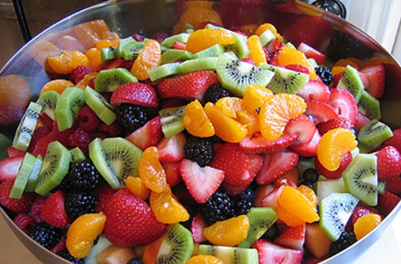
Fruit salad

Method:
- Prepare self – collect equipment and ingredients. Wash hands and put on apron

- Peel any fruit as needed – use the bridge claw cutting method to cut fruit into small even size pieces on a GREEN chopping board. Always do the hardest fruit with the least liquid in it last. For example apples and pears first.
- Put in container and pour over fruit juice.
- Wash all equipment with hot soapy water.

Ingredients:
Choose a maximum of 6 different fruits:
1 apple 6-12 grapes
1 pear 2 slices pineapple
1 clementine 1 slice melon
1 kiwi fruit 6 strawberries
1 peach /nectarine 200ml fresh fruit juice

Equipment:
Green chopping board, mixing bowl, spoon, knife, peeler, container

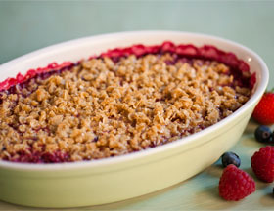
Fruit crumble
Method
- Prepare self – collect equipment and weigh out ingredients. Preheat oven to 180C / Gas 4
- Peel and chop fruit into small chunks. Place in the bottom of the dish/foil tray with 2 tablespoons water and 1 tablespoon of sugar.
- Place flour into a mixing bowl. Cut margarine into small pieces and add to flour.
- Rub margarine into the flour using fingertips. Shake bowl – any large lumps will come to the top. Continue rubbing in until mixture looks like breadcrumbs.
- Add sugar to flour mixture and stir in well.
- Add crumble mixture over the top of the fruit.
- Place in a preheated oven and cook for 20-30 minutes.
- Remove from oven leave to cool. Wash up.

Ingredients:
Topping:
150g plain flour
75g margarine/butter
50g sugar
Optional: 50g porridge oats
Fruit:
50g sultanas
2 large cooking apples
Optional: ½ tsp cinnamon/mixed spice
50g blackberries/pears/plums/strawberries
Equipment:
Mixing bowl, chopping board, peeler, knife, oven proof dish

Scones
Ingredients:

200g self-raising flour
50g margarine
100ml milk (approx.)
50g grated cheese
Optional:
Remove cheese
Add 25g sugar
25g dried fruit or fresh fruit
Citrus zest
Equipment:
Mixing bowl, knife, measuring jug, baking tray, round cutter
Method
- Prepare self – collect equipment and weigh out ingredients. Preheat oven to 220C/Gas 7.
- Place flour into mixing bowl. Cut margarine and add to the flour.
- Rub margarine into flour using fingertips. Shake bowl – lumps will come to the top. Continue rubbing until mixture looks like breadcrumbs.
- Add grated cheese and mix well (or sugar and fruit)
- Make a hole in the centre of the flour with fingertips.
- Beat egg/milk mixture a little at a time, mix with a round-bladed knife to a soft dough.
- Put on a clean floured surface and flatten to 3cm thickness with hands
- Cut out rounds with a cutter, place in a greased baking tray and glaze with milk using pastry brush.
- Place in a preheated oven and cook from 10 minutes.
10.Remove from oven. Place on a wire cooling rack

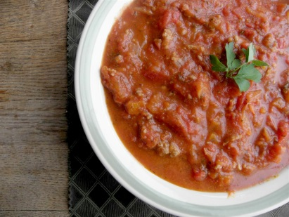
Bolognese sauce
Ingredients:
250g minced meat (lamb/beef)
400g chopped tomatoes
Medium onion
1 stock cube
1 tsp mixed herbs
1 garlic clove
Optional:
mushrooms, red / green pepper, Celery
Equipment:
Red chopping board, knife, saucepan, garlic crusher,
Method
- Prepare self – collect equipment and weigh out ingredients.
- Peel and chop onion, place in pan. Peel and chop the rest of the vegetables.
- Add oil to the pan and heat gently for 1 minute, stir. Add the mince to the pan and cook for 5 minutes or until completely browned. Add any other vegetables.
- Peel, crush and add the garlic clove to the pan and cook for a further 2 minutes.
- Add the tomato puree and tinned tomatoes and stir well. Increase the heat slightly and leave to simmer. Add stock cube and any other flavouring.
- If you need to adjust the recipe to make the Bolognese less thick add a little water. Simmer for a further 5 minutes.
- Wash, dry and clear everything away

